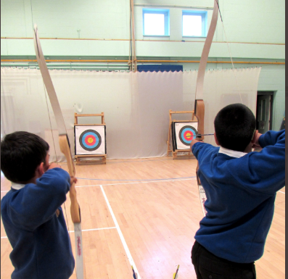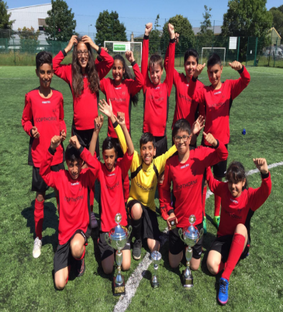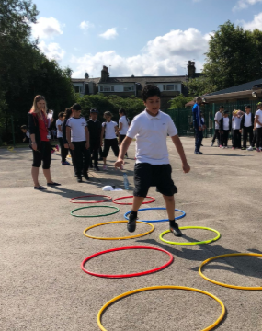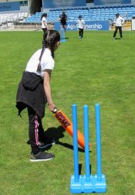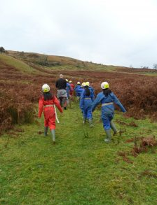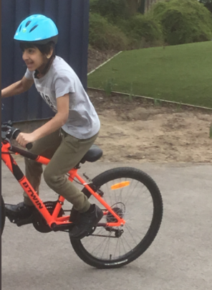

**Copthorne Primary School**

**Evidencing the impact of the PE & Sport Premium**

**Academic Year 2024-2025**



From March 2013 the Government has provided each school with funding annually to improve the quality of physical education (PE) and sport in primary schools. For the academic year 2024-2025 Copthorne Primary received **£19,630** PE and sport premium funding.

PE is an integral part of Copthorne’s curriculum through which we believe that every child has a right to the very best possible learning experiences and that everyone can succeed. Our ethos is one of no excuses, high expectations and hard work resulting in the provision of learning experiences and opportunities which challenge, support and meet the academic, personal, social and spiritual needs of every child.

At Copthorne we have always believed that we want our children to attain the highest standards in all that they do and become well rounded, healthy individuals. Therefore we support our children in every way possible to help them achieve this goal. We believe that PE and sport have a vital role to play in helping us to achieve our aims for our pupils. These important aspects of our curriculum teach our children to work together, learn good sportsmanship qualities, enjoy and value competitive activities and develop a clear understanding of the importance of PE in ensuring their long-term health and well-being in and outside of school. Consequently, we plan and deliver a curriculum that includes 2 hours of PE for each child within the school week: 1 indoor and 1 outdoor session.

We have also designed an extra-curricular timetable which places a strong emphasis on PE and sporting activities during school hours and after school hours.

This includes football, cricket, multi-skills, badminton, table tennis and archery clubs.

Below is a breakdown of:

* How much funding Copthorne Primary School has received
* A full breakdown of how we’ve spent the funding
* The effect of the premium on pupils’ PE and sport participation and attainment

|  |  |
| --- | --- |
| Meeting national curriculum requirements for swimming and water safety. |  |
| What percentage of your current Year 6 cohort swim competently, confidently and proficiently over a distance of at least 25 metres? | 74% |
| What percentage of your current Year 6 cohort use a range of strokes effectively [for example, front crawl, backstroke and breaststroke]? | 25% |
| What percentage of your current Year 6 cohort perform safe self-rescue in different water-based situations? | 25% |
| Schools can choose to use the Primary PE and Sport Premium to provide additional provision for swimming but this must be for activity **over and above** the national curriculum requirements. Have you used it in this way? | Yes |

|  |  |  |  |  |
| --- | --- | --- | --- | --- |
| **Academic Year:** 2024/25 | **Total fund allocated:** £19,630 | **Date Updated:** 01.09.2024 | |  |
| **Key indicator 1: The engagement of all pupils in regular physical activity – Chief Medical Officer guidelines recommend that primary school pupils undertake at least 60 minutes per day, with 30 minutes of this physical activity in school** | | | | Percentage of total allocation: |
| % |
| **Intent** | **Implementation** | | **Impact** |  |
| Your school focus should be clear what you want the pupils to know and be able to do and about what they need to learn and to consolidate through practice: | Make sure your actions to achieve are linked to your intentions: | Funding allocated: | Evidence of impact: what do pupils now know and what can they now do? What has changed?: | Sustainability and suggested next steps: |
| * To increase the number of pupils who meet the national curriculum swimming requirements by the end of Year 6, we are investing in additional swimming lessons for children in Years 3, 4, and 5. * Provide age- and ability-appropriate resources that support curriculum PE, active play, and extracurricular activities. * Learn to self-regulate and choose active options during unstructured times (e.g. break and lunch). | * Provide extra swimming sessions for pupils in Years 3–5, prioritising those with limited prior experience or low confidence. * Work with qualified swimming instructors to deliver high-quality, differentiated lessons. * Audit existing PE and playground equipment to identify gaps and safety issues. * Purchase new equipment as needed * Schedule structured physical activity sessions during lunch and break times e.g. cricket. * Target less active pupils through inclusive clubs and monitored participation. | £5961  £8423.24 | * Increased percentage of pupils achieving the national curriculum swimming standards by Year 6. * Pupils now engage in regular movement throughout the day, not just during PE lessons. * Increased participation in active play during break and lunch, including among previously less active pupils. | * Continue staff CPD to ensure confidence in delivering active learning across subjects. * Explore partnerships with local sports organisations to expand lunchtime and after-school activity options. |
| **Key indicator 2: The profile of PE and Sport being raised across the school as a tool for whole school improvement** | | | | Percentage of total allocation: |
| % |
| **Intent** | **Implementation** | | **Impact** |  |
| Your school focus should be clear what you want the pupils to know and be able to do and about  what they need to learn and to  consolidate through practice: | Make sure your actions to achieve are linked to your intentions: | Funding allocated: | Evidence of impact: what do pupils now know and what can they now do? What has changed?: | Sustainability and suggested next steps: |
| * Recognise PE and sport as valued, high-status subjects within the school. * Develop children’s confidence, leadership, and teamwork skills through sporting opportunities. | * Celebrate sporting achievements in assemblies, on Class Dojo, in newsletters and displays to raise visibility and pride. * Provide CPD for staff to confidently deliver high-quality PE and integrate sport into wider learning. * Host whole-school events e.g. sports days |  | * Pupils show greater enthusiasm and pride in physical achievements and teamwork. * Staff report that sport has become a valuable tool for teaching resilience & cooperation | * Introduce pupil sports leaders to support younger children, lead activities, and promote responsibility. * Create a long-term calendar of events to ensure consistent visibility and celebration of sport. |

|  |  |  |  |  |
| --- | --- | --- | --- | --- |
| **Key indicator 3: Increased confidence, knowledge and skills of all staff in teaching PE and sport** | | | | Percentage of total allocation: |
| % |
| **Intent** | **Implementation** | | **Impact** |  |
| Your school focus should be clear | Make sure your actions to | Funding | Evidence of impact: what do | Sustainability and suggested |
| what you want the pupils to know | achieve are linked to your | allocated: | pupils now know and what | next steps: |
| and be able to do and about | intentions: |  | can they now do? What has |  |
| what they need to learn and to |  |  | changed?: |  |
| consolidate through practice: |  |  |  |  |
| Support staff to:   * Gain secure subject knowledge and practical strategies for teaching PE & Swimming effectively. * Feel confident in differentiating activities to meet the needs of all pupils. * Understand how to assess progress in PE and provide meaningful feedback. * Be empowered to use PE as a tool for developing wider skills such as teamwork, resilience, and leadership. | * Staff CPD for teachers, support staff and lunchtime supervisors * Staff to observe the Kanga swimming instructor delivering swimming lessons and be given discussion time * Use team teaching, pairing less confident staff with experienced colleagues or coaches. * Develop clear PE planning and assessment tools to support consistency and progression. * Gather staff feedback regularly to tailor support and identify areas for development. * Celebrate staff achievements in PE delivery to build morale and motivation. * Complete PE subscription & PE Association Membership | £762.47    £250 | * Staff now demonstrate greater confidence and competence in delivering PE lessons. * Lessons are more inclusive, engaging, and structured, with clear learning outcomes. * Pupils benefit from higher-quality instruction, leading to improved skill development and enjoyment. * Staff are more willing to experiment with new approaches * Greater accuracy and consistency in assessment | * Develop a staff PE handbook with planning, assessment, and differentiation strategies. * Further training for support staff and lunchtime supervisors |
| **Key indicator 4: Broader experience of a range of sports and activities offered to all pupils** | | | | Percentage of total allocation: |
| % |
| **Intent** | **Implementation** | | **Impact** |  |
| Your school focus should be clear | Make sure your actions to | Funding | Evidence of impact: what do | Sustainability and suggested |
| what you want the pupils to know | achieve are linked to your | allocated: | pupils now know and what | next steps: |
| and be able to do and about | intentions: |  | can they now do? What has |  |
| what they need to learn and to |  |  | changed?: |  |
| consolidate through practice: |  |  |  |  |
| Support pupils to:   * Explore new and diverse sports beyond the traditional curriculum. * Discover activities that match their interests, strengths, and needs. * Build confidence and motivation through exposure to alternative forms of physical activity. * Develop a well-rounded skill set, including coordination, teamwork, and perseverance. | * Take part in the Sports Festival which includes a range of new sports e.g. golf, frisbee * Offer inclusive clubs – archery, badminton, Commando Joes, cycling * Year 6 Residential & Year 4 Doe Park including orienteering, canoeing & hiking | £2392.11  £1741.18 | * Pupils now have greater exposure to a variety of sports, increasing engagement and enthusiasm. * Increased participation in extracurricular clubs * Pupils demonstrate new skills and interests, with some pursuing sports outside of school. * Staff report that pupils are more motivated and open to trying new challenges. | * Use pupil voice surveys to identify interests and shape the activity offer. |

|  |  |  |  |  |
| --- | --- | --- | --- | --- |
| **Key indicator 5: Increased participation in competitive sport** | | | | Percentage of total allocation: |
| % |
| **Intent** | **Implementation** | | **Impact** |  |
| Your school focus should be clear | Make sure your actions to | Funding | Evidence of impact: what do | Sustainability and suggested |
| what you want the pupils to know | achieve are linked to your | allocated: | pupils now know and what | next steps: |
| and be able to do and about | intentions: |  | can they now do? What has |  |
| what they need to learn and to |  |  | changed?: |  |
| consolidate through practice: |  |  |  |  |
| Support pupils to:   * Experience the excitement and challenge of competition in a supportive environment. * Develop key values such as teamwork, resilience, respect, and sportsmanship. * Build confidence and aspiration through representing their school and achieving personal goals. * Understand that competition can be inclusive and developmental, not just about winning. | * Develop Sports Days as intra-school competitions with teams from across school * Enter the inter-school Sports Festival * Celebrate participation and achievement through assemblies, Class Dojo, newsletters and displays. | £100 | * An increase in the number of pupils participating in competitive sport, both internally and externally. * Pupils demonstrate greater resilience, teamwork, and pride in representing their school. * Improved confidence and motivation, especially among pupils who previously lacked engagement. | * Embed competitive sport into the school calendar, with termly events |
| **Total £19,630** |  |  |  |  |

|  |  |
| --- | --- |
| Signed off by | |
| Head Teacher: | Stephanie Ngenda |
| Date: | 30.07.2025 |
| Subject Leader: | Jabran Darr |
| Date: | 30.07.2025 |