Working
With Us

RECRUITMENT INFORMATION PACK

Position: Site Manager at Copthorne Primary School Grade: Band 7, SCP11-SCP17 - November 2021

Contents
MESSAGE FROM THE CEO 2
ABOUT US 3
OUR PURPOSE AND ETHICAL GOALS 4
COPTHORNE PRIMARY SCHOOL 5
JOB ADVERT 6
JOB DESCRIPTION AND PERSON SPECIFICATION 8

MESSAGE FROM THE CEO

Dear Candidate,
We would like to thank you for your interest in joining Exceed Academies Trust as the Site Manager at Copthorne Primary School.
I am delighted that you are interested to see how Exceed Academies Trust can support you in your career. You may already know a little bit about our amazing schools, we hope that after reading the enclosed pack that you will consider applying to be part of our outstanding team.
Exceed Academies Trust is an educational charity that runs schools on behalf of the Government. We are a cross phase Trust comprising of eight schools: six primaries, one all-through (3-16), and one alternative provision academy. Our family of schools are all located within the Bradford district and mostly serve communities with some of the highest levels of social and economic challenges in the city. Our schools are inclusive, community focused, and supportive. We make no excuses for outcomes and a number of our schools have traditionally been some of the highest performing both locally and nationally, with two schools featuring in the Sunday Times list of top 250 state primary schools in the country. Our Sponsored Academies are being supported on their journey to Outstanding, one of which was recently rated in the top five in Bradford for its amazing KS2 Outcomes.
Exceed Academies Trust recognises its moral purpose to support schools and academies across the city and the region. Exceed Academies Trust is responsible for and runs the Bradford Teaching School Hub on behalf of the City. The Trust is also responsible for a SCITT (School Centre for Initial Teaching Training) and has recently been approved as an Apprenticeship Training Provider. The SCITT trains 50 primary school teachers each year and has two hubs, one in Leeds and one in Bradford.
As a Trust, we are determined to be an ‘Employer of Choice’ where our staff are seen as the key and the most important resource. Our staff are supported through professional development and an active wellbeing strategy. We believe in supporting staff to achieve a healthy work life balance, for the benefit of the children in our schools, as well as to support them to enjoy their personal lives, family and social time. We are keen to support initiatives that build healthy teams, support personal resilience and we provide opportunities to seek support for staff mental health and general wellbeing.
I would like to thank you once again for your interest in Exceed Academies Trust and the position at Copthorne Primary School. I hope the information provided gives you a sense and feel for our organisation. If you believe that your own values are a good fit with our Trust, we would be delighted to receive your application and look forward to working with you to support the children and young people of Bradford.

Duncan Jacques, CBE Chief Executive Officer, Exceed Academies Trust

ABOUT US
Exceed Academies Trust believes that successful schools develop their own identity and individuality and are best placed to meet their own community’s needs. We believe that partnership working, the sharing of good practice and being outward facing as an organisation supports our aims and leads to outstanding results.
We are a cross phase Trust of eight academies; six primary, one all-through, and one alternative provision academy; we also run a maintained nursery school through a service level agreement. It is our aim and determination to be as inclusive as possible.
Each academy has its own website, please visit these websites to find out more about the academy where you will be working.

The Trust recognises its moral purpose to support schools and academies across the city and the region. We are responsible for running and managing the Bradford Teaching School Hub on behalf of the DfE, deliver high-quality school-led Initial Teacher Training through our Ofsted Outstanding SCITT, and facilitate a wide range of school improvement support for Exceed Academies Trust and beyond through our Institute.

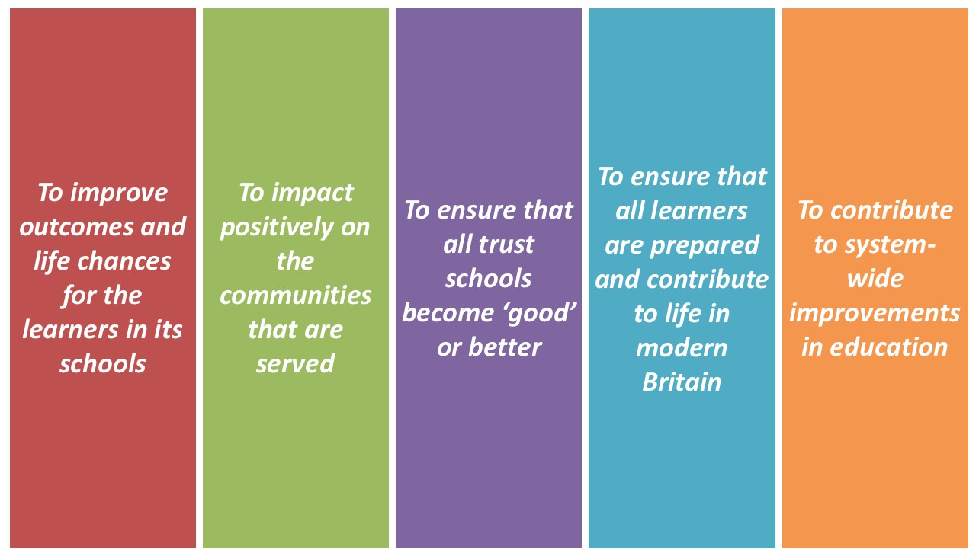
OUR PURPOSE AND ETHICAL GOALS
Our core educational vision is to provide an
outstanding school experience for all.

Our schools aim to be inclusive, high achieving and ones in which our learners, staff and the wider community strive to ‘see what’s possible’.

Our schools retain their individuality, own identity and local governance.

The Trust recognises its moral purpose to support schools and academies across the city and the region.

Children and students are at the heart of everything we do

Our tagline is simple:

All of our work is underpinned by our ethical goals:

COPTHORNE
PRIMARY SCHOOL

Copthorne Primary is a busy and exciting 2 form entry school with excellent facilities. The age range of children attending is 2-11 and the school includes an 80 place nursery and 48 place 2 year old provision. We believe that there are no limits on learning and are committed to maintaining our high standards and highly effective community partnerships. Copthorne is the lead school in the Exceed Teaching School Alliance. We have an excellent reputation within the local and wider community and an outstanding track record of supporting staff to grow and develop their careers.

Our children thrive in a happy, safe and supportive learning environment. Throughout their time here children are encouraged to love learning, work hard and welcome and meet the challenges that new learning brings. We pride ourselves on having the highest expectations of all our children and believe that there are no limits on what they can achieve. At the heart of the school is our commitment to work in partnership with parents, carers and the local community to raise aspirations for all and to provide a high quality education for every child. Our goal is to ensure that each individual has the skills and knowledge needed to succeed in life and to become a lifelong learner.

Demographic Context
Latest Published Results Data

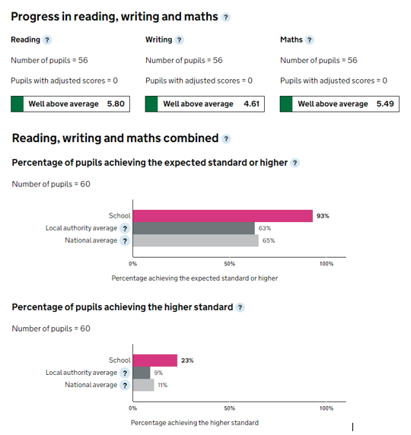
The school is situated in an area of significant social and economic deprivation. The deprivation indicator is currently in the highest band nationally and the Ward Deprivation figure states that 35.9% of families are living in neighbourhoods which are within the top 10 percentile of most deprived in England.

The school’s ethnic groups are made up largely of Pakistani 91.5% and the next largest group is Indian at 2.9%, African 1.5% Bangladeshi 1.2%, Eastern European 0.8% and other 0.8%.

JOB ADVERT

Site Manager – Copthorne Primary School

Band 7, SCP11-SCP17 - £21,166 to £23,836 per annum
37.5 hours per week, permanent, all year round
(Hours of work will be 6.30am – 2.30pm, with 30 minute unpaid lunch break)

A new and exciting opportunity has arisen for an experienced Site Manager to join Copthorne Primary School, which is part of the Exceed Academies Trust.

The Site Manager plays a key role at the school. You will be working closely with the Headteacher and Senior Leadership Team to not only manage the security of the building but to take a pro-active role in the maintenance and management of our whole school site.

You will be the first point of contact for staff regarding maintenance and you will therefore be very customer focused, polite and helpful. You will manage a dedicated team of cleaning staff and you will have great interpersonal skills to support and direct the team to create an outstanding learning environment for our pupils.

You will work with the Chief Estates Officer for the Trust to ensure that the school complies with all requirements of Health and Safety and risk management, and you will liaise with contractors and external agencies to ensure our school site is clean, safe and provides pupils and staff with a great place to learn and work.

Being part of our Multi-Academy Trust means that the Site Manager will have a team of colleagues across the other Trust schools to work and collaborate with.
The successful candidate will:
- Undertake a variety of duties relating to maintenance of the buildings and grounds
- Be responsible for, and promote, the health and safety of all staff, pupils and visitors
- Maintain the security of the premises, working closely with the Head of School/ Executive Headteacher
- Have a flexible approach and the ability to use their initiative
- Possess excellent communication skills
- Have a strong work ethic
We can offer:
- A dedicated and experienced staff team, supported by governors and parents
- An opportunity to make a significant contribution to our ongoing improvements
- An opportunity to further professional development
- Access to excellent training and guidance

Recruitment process

Exceed Academies Trust believes in equal opportunities for all staff. As part of that commitment, all vacancies will be advertised and filled through a transparent recruitment and selection process.

For an informal discussion regarding this opportunity, please contact Emma Hendry, Chief HR Officer on 07967390793 or emma.hendry@exceedacademiestrust.co.uk

Application packs should be downloaded from the Trust website: www.exceedacademiestrust.co.uk or the school website: www.copthorneacademy.co.uk

Closing date for applications: Friday 26th November 2021 - 12.00 noon
Interviews: Friday 3rd December 2021

Please submit completed applications to cprecruitment@copthorneacademy.co.uk

Candidates should complete a full application form by the closing date in order for their application to be considered. CVs will not be accepted.

Exceed Academies Trust is committed to safeguarding and promoting the welfare of children and young people and expects all staff to share this commitment.

JOB DESCRIPTION AND PERSON SPECIFICATION
Post Title: Site Manager
Pay Range/Grade: Band 7, SCP 11 – SCP 17
Reporting to: Headteacher
Line Management of: Cleaning Staff

Core purpose:
- Under the guidance of appropriate senior staff: be responsible for compliance, maintenance, security and facilities management services on school sites and premises and provide specialist support in a specific resource area be responsible for the maintenance of a clean and hygienic school interior.
- May from time to time be required to undertake other duties commensurate with the grade and level of responsibility defined in this job description.

Duties and responsibilities:

Effort Demands:
- Will work under own initiative with minimum supervision, managing conflicting priorities and referring only extremely complex issues to a member of the senior leadership team.
- Contribute to the planning, development and organisation of systems/procedures/policies.
- Responsible for the development and operation of a preventative planned maintenance programme and for routine inspections of the buildings, fixtures, fittings, furniture, premises and grounds to assess for work or repairs required to be carried out to maintain safe and satisfactory conditions (including all school compliance checks, fire safety and electrical equipment) and to maintain appropriate, accurate records.
- Undertake the procurement of school related site works and ordering of associated stocks and supplies ensuring that there are adequate levels at all times to meet the needs of the school within budgetary parameters. Taking delivery and arranging for the storage of materials, stores and other goods.
- Ensure all contractors on site are managed and delivery works in line with school policies and HSE regulations.

Responsibilities:
- Have an in-depth knowledge of and ensure compliance with policies and procedures relating to child protection, health, safety and security and confidentiality at all times, reporting all concerns to an appropriate person.
- Promote and ensure the health and safety of pupils, staff & visitors (in accordance with appropriate health & safety legislation) at all times. (This responsibility is shared during normal school hours with the Headteacher, but is the potholder’s sole responsibility whilst on site outside of these hours in the absence of the Headteacher or other senior member of the school staff).
- Responsibility for the statutory compliance, maintenance and security of the premises, advising the Headteacher of any problems with appropriate suggestions for solutions/improvements.

- Responsible for the line management and performance appraisal of designated employees, maintaining good working relationships employing effective leadership techniques. Ensure timely completion of all related paperwork associated with the management of employees. Identify and implement necessary work-related training.
- Control expenditure and set allocated budgets for staffing, annual site maintenance and capital budgets, to ensure that budgets are not overspent and best value is achieved.
- Identify and create business opportunities and to assist in the external marketing of Facilities Services for the school, in particular, this will involve creating revenue through school facilities and developing pricing strategies.
- Attend and participate in relevant meetings, producing analysis and reports as required.
- Participate in training and other learning activities and performance development as required.
- Establish constructive relationships and communication with contractors and other agencies/professionals, ensuring that contracts on site do not cause a health and safety hazard or damage school property. Report matters of concern or noncompliance with contract specification to the relevant contractor.
- Contribute to the overall ethos/work/aims of the school and appreciate and support the role of other professionals.
- Insure the highest standards of professional conduct and confidentiality at all times.
- Present a positive personal image, contributing to a welcoming school environment which supports equal opportunities for all, treating all users of the school with courtesy and consideration.

Environmental Demands/Working Conditions:
- Required to be a key-holder for emergency call-outs. Evening/weekend duties for lettings may be a feature of the job (further information is available from the Head-teacher).
- Regular outdoor work and exposure to the elements/weather.
- Will have contact with members of the public/other professionals e.g. teaching staff, governors, parents/carers, community groups, local education authority, external providers etc.
- The post holder may occasionally be subjected to antisocial behaviour from members of the public/parents/site users.
- This post may include a degree of manual lifting and handling. You are expected to be aware of health and safety policies and procedures and frequently assess your ability to carry out the lifting tasks required of you.

Fluency Duty:
- In line with the Immigration Act 2016; the Government has created a duty to ensure that all Public Authority staff working in customer facing roles can speak fluent English to an appropriate standard.
- For this role the post holder is required to meet the Intermediate Threshold Level

Intermediate Threshold Level:
The post holder should demonstrate:
- They can express themselves fluently and spontaneously with minimal effort and,
- Only the requirement to explain difficult concepts may hinder a natural smooth flow of language.

Special Conditions of Service:
- No contra-indications in personal background or criminal record indicating unsuitability to work with children/young people/vulnerable clients/finance (An enhanced DBS check is required).

Other Considerations:
- To be aware of and comply with policies and procedures relating to child protection; being vigilant for signs that children may be being abused and to report any such suspicions to the school’s nominated Child Protection Co-ordinator or the Headteacher.
- To act in accordance with the Data Protection Act and maintain confidentiality at all times e.g. access to staff/student/parent and carers files.
- Accept and commit to the principles underlying the Schools Equal Rights policies and practices.
- Will be able to maintain the mini busses and drive them when necessary.
- Be able to perform all duties and tasks with reasonable adjustment, where appropriate, in accordance with the Equality Act.
- Must be legally entitled to work in the UK.

Person Specification

 | Essential | Desirable
Qualifications | - Good literacy, ICT and numeracy skills (GCSE (or equiv) Maths and English).
Knowledge, Skills and Experience | - In line with the Immigration Act 2016; you should be able to demonstrate fluency of the English Language at an Intermediate Threshold Level.  - Experience of working as a handyperson, caretaking.  - Experience of cleaning/site- keeping experience in a school or similar environment.  - Detailed knowledge of all policies, procedures and regulations relevant to the role.  - Knowledge of cleaning procedures required to meet specified cleaning standards.  - Experience of team-leading skills.  - Experience of the ability to relate well to children and adults. | - Provide evidence of having previously spoken fluently to customers at an Intermediate Threshold Level.  - Detailed knowledge of plumbing, electrical and decorating repair procedures.  - Detailed knowledge of HSE regulations relating to schools compliance requirements, policies and processes.  - Knowledge of the use of ICT and other specialist equipment/resources with willingness to participate in development and training opportunities.  - Ability to self-evaluate learning needs and actively seek learning opportunities.

