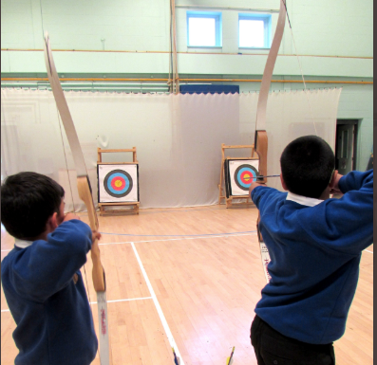
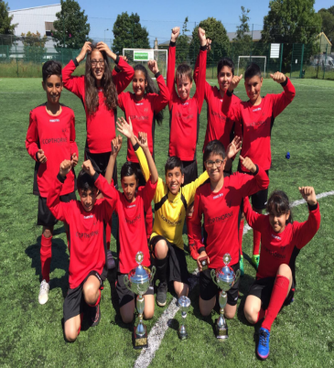
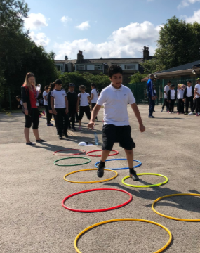
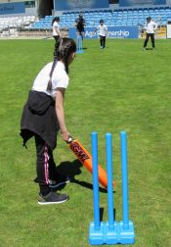
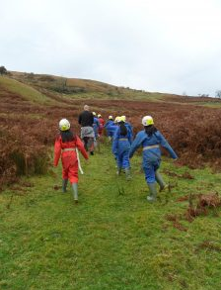
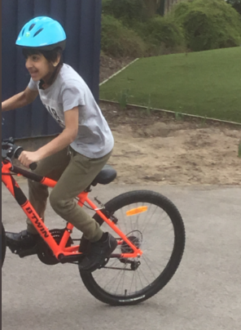

Copthorne Primary School
Evidencing the impact of the PE & Sport Premium
Academic Year 2019-2020

From March 2013 the Government has provided each school with funding annually to improve the quality of physical education (PE) and sport in primary schools. For the academic year 2019-2020 Copthorne Primary received £19,710 PE and sport premium funding.

PE is an integral part of Copthorne’s curriculum through which we believe that every child has a right to the very best possible learning experiences and that everyone can succeed. Our ethos is one of no excuses, high expectations and hard work resulting in the provision of learning experiences and opportunities which challenge, support and meet the academic, personal, social and spiritual needs of every child.

At Copthorne we have always believed that we want our children to attain the highest standards in all that they do and become well rounded, healthy individuals. Therefore we support our children in every way possible to help them achieve this goal. We believe that PE and sport have a vital role to play in helping us to achieve our aims for our pupils. These important aspects of our curriculum teach our children to work together, learn good sportsmanship qualities, enjoy and value competitive activities and develop a clear understanding of the importance of PE in ensuring their long-term health and well-being in and outside of school. Consequently, we plan and deliver a curriculum that includes 2 hours of PE for each child within the school week: 1 indoor and 1 outdoor session.

We have also designed an extra-curricular timetable which places a strong emphasis on PE and sporting activities during school hours and after school hours.

This includes football, cricket, multi-skills, badminton, table tennis and archery clubs.

Below is a breakdown of:

- How much funding Copthorne Primary School has received
- A full breakdown of how we’ve spent the funding
- The effect of the premium on pupils’ PE and sport participation and attainment

Meeting national curriculum requirements for swimming and water safety.

Due to COVID 19 restrictions, the cohort of Year 5 children attending swimming lessons did not complete their sessions.
Children will complete catch up sessions during 2020- 2021, to ensure that they meet National Curriculum requirements by the end of Year 6.
What percentage of your current Year 6 cohort swim competently, confidently and proficiently over a distance of at least 25 metres?  N.B. Even though your pupils may swim in another year please report on their attainment on leaving  primary school at the end of the summer term 2020. | %
What percentage of your current Year 6 cohort use a range of strokes effectively [for example, front crawl, backstroke and breaststroke]? | %
What percentage of your current Year 6 cohort perform safe self-rescue in different water-based situations? | %
Schools can choose to use the Primary PE and Sport Premium to provide additional provision for swimming but this must be for activity over and above the national curriculum requirements. Have you used it in this way? | Yes/No

Academic Year: 2019/20 | Total fund allocated: £19,710 | Date Updated: 30.07.2020
Key indicator 1: The engagement of all pupils in regular physical activity – Chief Medical Officer guidelines recommend that primary school pupils undertake at least 30 minutes of physical activity a day in school |  |  |  | Percentage of total allocation:
 |  |  |  | %
Intent | Implementation |  | Impact
Your school focus should be clear what you want the pupils to know and be able to do and about  what they need to learn and to  consolidate through practice: | Make sure your actions to achieve are linked to your intentions: | Funding allocated: | Evidence of impact: what do pupils now know and what can they now do? What has changed?: | Sustainability and suggested next steps:
Continue to maintain and improve  resources to support PE, including  transport and equipment. | - Refresh PE apparatus  - Replenishment of resources across school  - Upkeep of transport to take children to and from tournaments, swimming and local activities | £2000  £1000 | - Initial spend has ensured that all planned PE sessions have been fully resourced leading to greater participation and activity in lessons.  - Equipment audit by PE coordinator linked to club planning shows all activities are well resourced | - Continued monitoring of PE resources for wear and tear and purchasing plan to ensure all sports offered during the day and through after school clubs are adequately resourced.  - Continue to widen range of resources so a wider variety of sports can be offered.
Key indicator 2: The profile of PESSPA being raised across the school as a tool for whole school improvement |  |  |  | Percentage of total allocation:
 |  |  |  | %
Intent | Implementation |  | Impact
Your school focus should be clear what you want the pupils to know and be able to do and about  what they need to learn and to  consolidate through practice: | Make sure your actions to achieve are linked to your intentions: | Funding allocated: | Evidence of impact: what do pupils now know and what can they now do? What has changed?: | Sustainability and suggested next steps:
To further raise the profile of PE and Sport within the school and the local community, creating an improved sense of enthusiasm of participation and pride in the school amongst pupils. | - Daily Mile implemented across the school for all year groups. This consists of children completing a mile a week with their class teacher. Their times and laps are recorded and monitored.  - At the end of each half term, PE monitors check which classes have run the most miles.  - Winning classes from each Key Stage are celebrated in achievement assembly and a prize is awarded.  - PSHCE week – focus all teaching and learning on matters related to personal health and wellbeing.  - Sports day - wide range of activities for the whole school to participate in | n/a  £3000  £200 | Daily mile timetable and circuit is now displayed centrally, resulting in a better understanding of expectations and engagement from all staff.  Class tracking sheets show increased participation throughout school.  Pupil voice demonstrates that children understand the importance of daily physical activity.  Skills, talents and achievements have been celebrated which in turn have raised children’s self-confidence and positivity towards sports and physical activity.  Did not take place due to COVID 19.  Did not take place due to COVID 19. | - Regularly share results from intra and inter-school competitions on the school’s Twitter page and through Marvellous Me.

Key indicator 3: Increased confidence, knowledge and skills of all staff in teaching PE and sport |  |  |  | Percentage of total allocation:
 |  |  |  | %
Intent | Implementation |  | Impact
Your school focus should be clear | Make sure your actions to | Funding | Evidence of impact: what do | Sustainability and suggested
what you want the pupils to know | achieve are linked to your | allocated: | pupils now know and what | next steps:
and be able to do and about | intentions: |  | can they now do? What has
what they need to learn and to |  |  | changed?:
consolidate through practice:
To maintain and raise the standards of pupil attainment and progress in PE by increasing teacher confidence, knowledge and skills through professional development. | - Time provided for PE coordinator to review and develop long term planning and PE curriculum plans across school.  - CPD for staff all teachers to review plans from year groups other than their own to check progression through school. |  | As a result of good leadership and confident and knowledgeable staff, pupils in all year groups made good or better progress, building on prior achievement. | The subject leader will be allocated staff meeting time to ensure all staff are have a good understanding of skills development in sports and the schools assessment of PE.
Key indicator 4: Broader experience of a range of sports and activities offered to all pupils |  |  |  | Percentage of total allocation:
 |  |  |  | %
Intent | Implementation |  | Impact
Your school focus should be clear | Make sure your actions to | Funding | Evidence of impact: what do | Sustainability and suggested
what you want the pupils to know | achieve are linked to your | allocated: | pupils now know and what | next steps:
and be able to do and about | intentions: |  | can they now do? What has
what they need to learn and to |  |  | changed?:
consolidate through practice:
▪ To promote enjoyment of being in the outdoors and participate in a variety of outdoor activities, adopting a positive attitude to challenge and adventure.  Improve the percentage of children leaving Year 6 at the expected standard in swimming. | Year 3 and Year 6 residential (Buckden house and Nell Bank - including activities such as high ropes, raft building, orienteering, climbing and canoeing). This amount will subsidise the total cost to the families, encouraging more children to participate.  - Swimming for all Year 5 children and the addition of swimming in Year 6 for those pupils who did not reach NC standards. | £2,535  £1000 not spent due to COVID 19.  £12,000  £8320 spent | Year 3 residential did not take place due to COVID 19.  All pupils demonstrated a ‘can do’ attitude and willingness to try hard and keep going.  Pupil voice demonstrated that 100% of pupils reported positively about their new experiences and said they felt that the experiences increased their confidence.  No catch up classes took place due to COVID 19.  Girls in Year 5 did not attend swimming lessons due to COVID 19. | Include opportunities for children to attend Buckden House as a day trip rather than a residential, in line with COVID restrictions.  Improve the percentage of children leaving Year 6 at the expected standard in swimming.  Swimming for children in Year 3 and 5.  Catch up sessions for children in Year 6 who did not complete lessons.

Key indicator 5: Increased participation in competitive sport |  |  |  | Percentage of total allocation:
 |  |  |  | %
Intent | Implementation |  | Impact
Your school focus should be clear | Make sure your actions to | Funding | Evidence of impact: what do | Sustainability and suggested
what you want the pupils to know | achieve are linked to your | allocated: | pupils now know and what | next steps:
and be able to do and about | intentions: |  | can they now do? What has
what they need to learn and to |  |  | changed?:
consolidate through practice:
▪ To increase the number of intra-school and inter-school opportunities for pupils. | - Football tournament  - Netball tournament  - Archery tournament  - Cricket tournament  - EXCEED sports day  - Hockey tournament | £100 each  Total £600 | Did not take place due to COVID 19 | Apply for school Games Mark in 2020 – 2021. In order to do this, we need to increase our competitive sport rate at both Level 1 (intra-school) and Level 2 (inter-school).
Total £21, 335
£8480 not spent due to COVID 19

Signed off by
Head Teacher: | Stephanie Ngenda
Date: | 03.08.2020
Subject Leader: | Aroosa Ahmed
Date: | 30.07.2020

