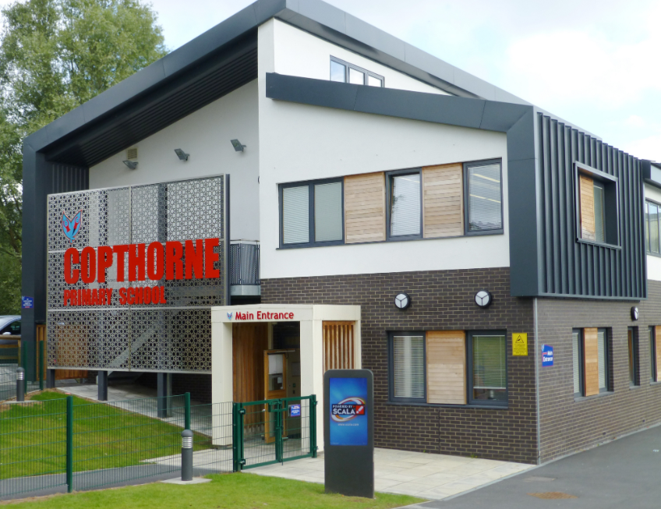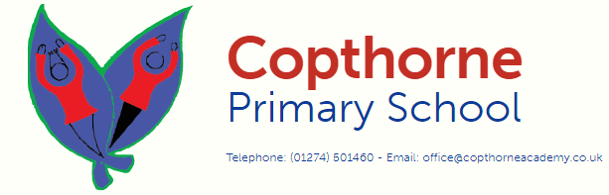

Saplings begins promptly at 8:30 for the morning children and 12:15 for the afternoon children. Learning begins at these times so please ensure your child is on time every day. If you and your child arrive after this time, you **MUST** report to the school office, where your child will be escorted to their class and given a late mark.

If you have any questions please phone the school office or contact us.

Copthorne Primary School  
All Saints Road  
Bradford  
BD7 3AY

Tel: 01274 501460

Email: office@copthorneacademy.co.uk

We are very excited that you will be part of our school. Please use this booklet to provide you with all the information you will need before your child starts with us.

**Welcome to Saplings**

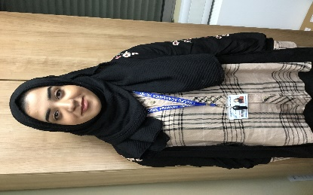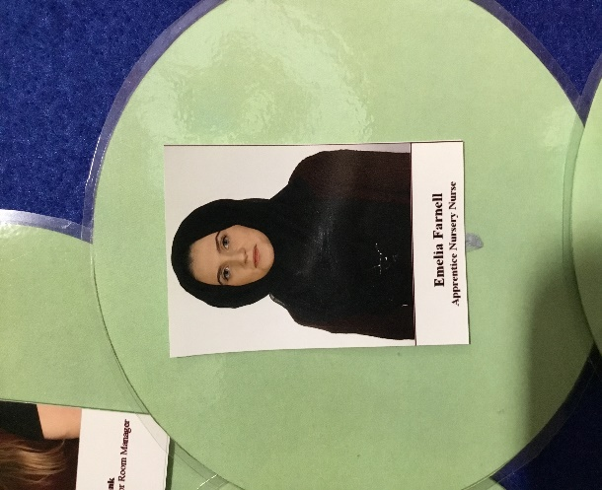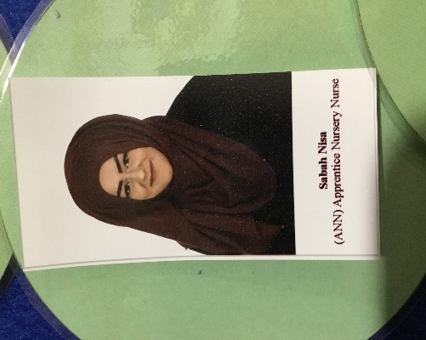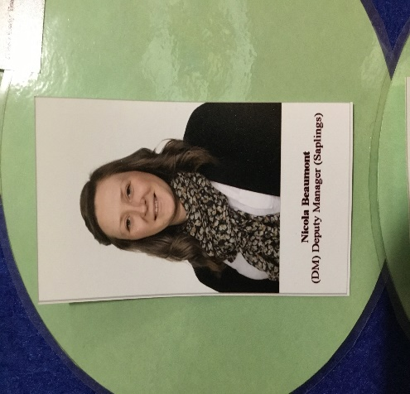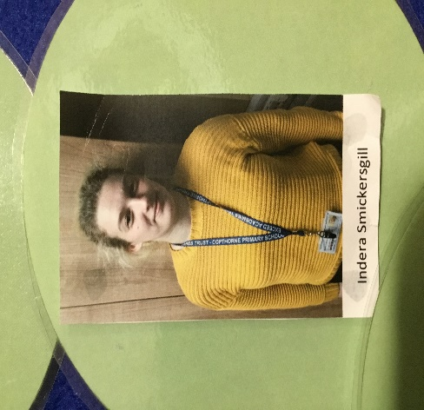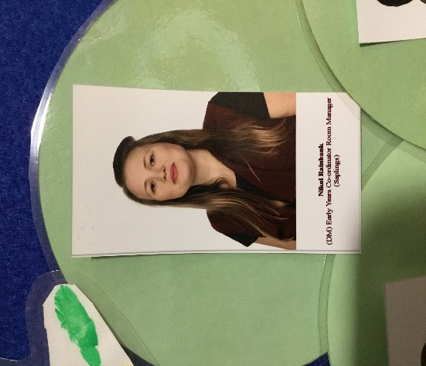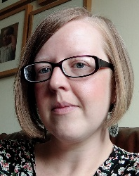

Saplings Teachers

Your child will be allocated to a Key Person. They will take a close interest in your child’s progress and individual needs.

Your child will spend time with their Key Person throughout the day and during any group work.

If you have any concerns about your child throughout their time in Saplings, you are advised to speak to your child’s Key Person.

Please remember:

• Holidays **MUST NOT** be taken during school term time.

• If your child is ill, you must telephone the school office to notify us.

• Any medical appointments taken during the school day, must be pre-authorised by the Head of School.

• At Copthorne, we have a large number of children on the waiting list for our 2 year old provision. If your child is persistently absent, they will risk losing their place to someone on the waiting list.

• Jewellery and watches should not be worn as the school cannot accept responsibility for loss or damage to these.

• If you have any queries, concerns or questions please speak to your child’s Key Person, Nikol or please contact the school office.

**We look forward to**

**seeing you in September!**

Miss Kneeshaw Nikol Rainbank Nicola Beaumont Emelia Farnell

Sabah Nisa Khizrah Mateen Indira Smickersgill Sarin Bibi

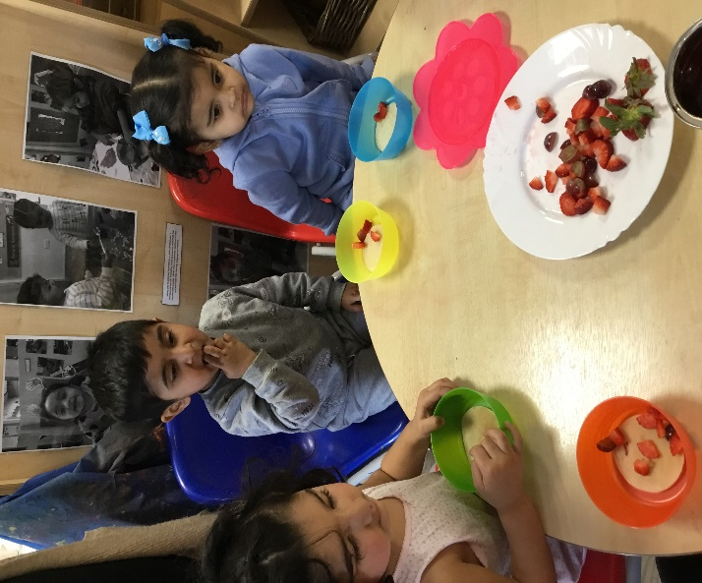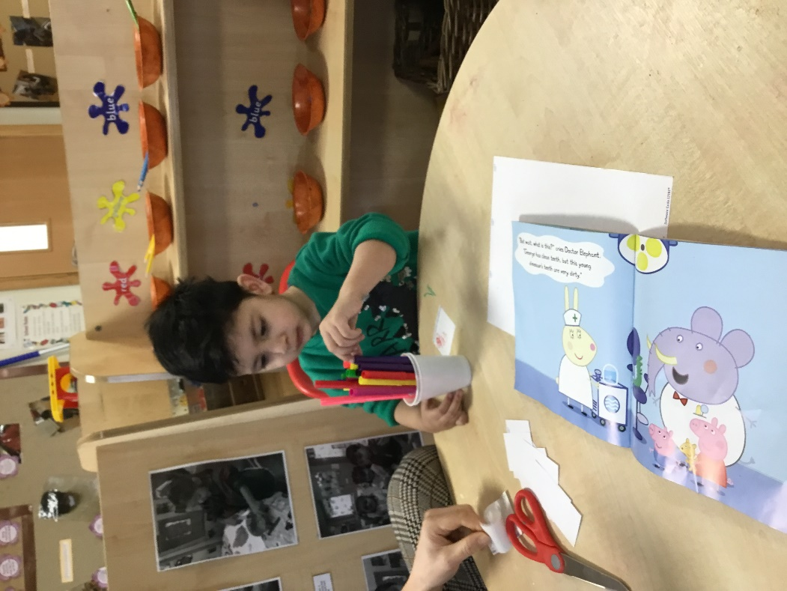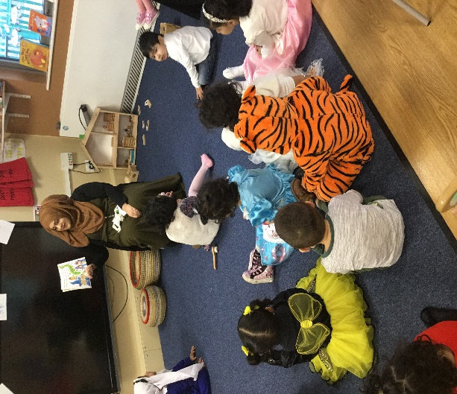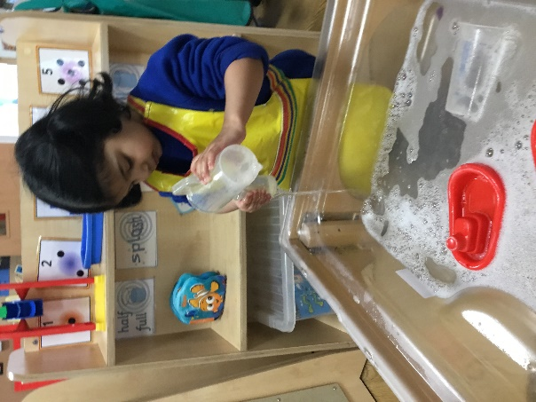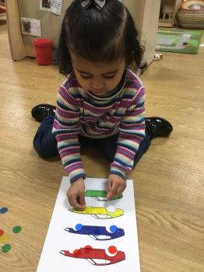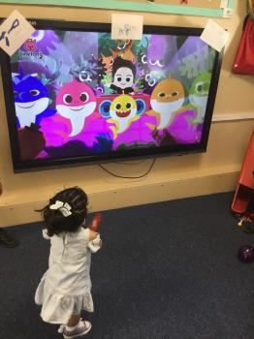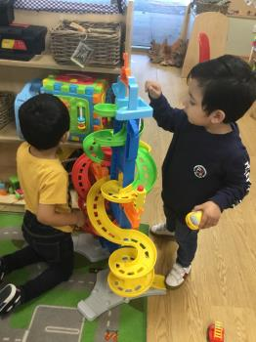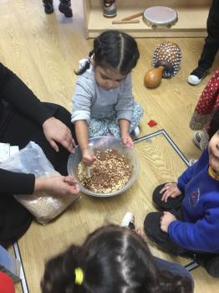

Saplings

Saplings

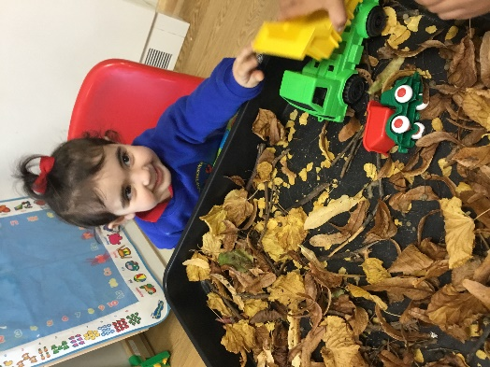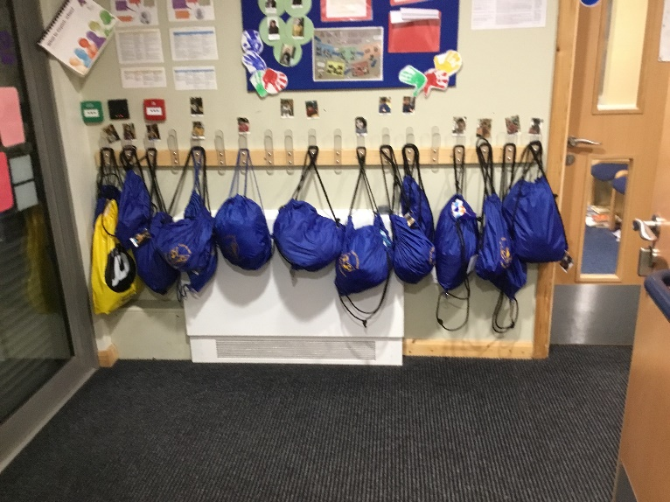

Where your things go

This is the cloakroom where you will have a peg with your name on. Please encourage your child to take their own coat off and hang it up so they can do it when you’re not there to do it for them!

Please don’t bring any toys to school with you as they might get lost or broken.

What you can do in Saplings

In Saplings you play and share toys, talk to

others and pretend play. This helps to learn about your likes, interests and the world you live in as well as developing social skills.

You will make friends. As well as building up your confidence to sing songs and rhymes and listen to stories.

You will learn about books, how to turn the pages, talk about the pictures and how to look after them. You will take part in

activities which help to develop your body such as climbing, running, playing football, dancing, painting, drawing, glue or dough, finger painting and sand and water play.

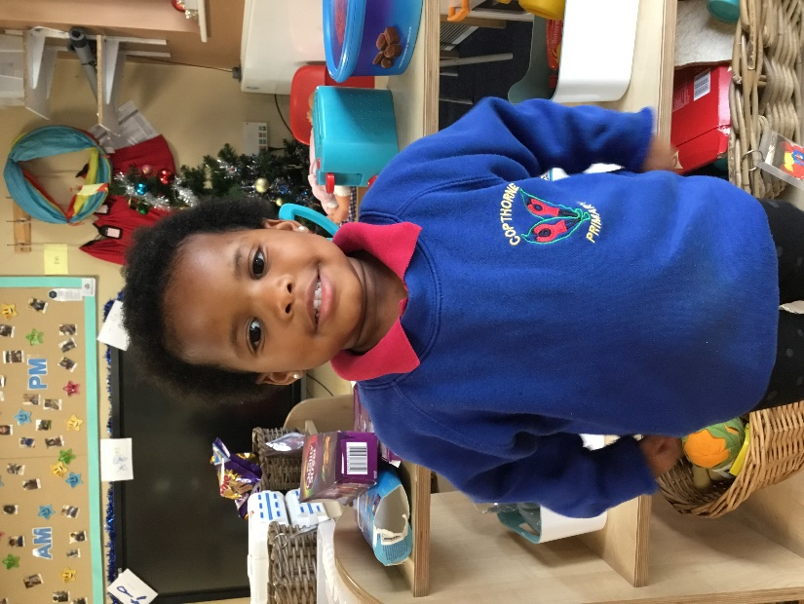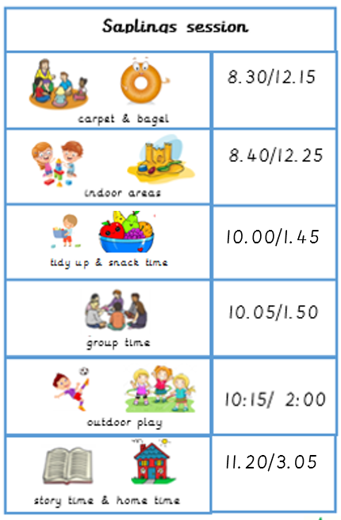

What you will wear

You will be given one free school jumper when you first start in Saplings which should be worn everyday . With this you will be able to wear any bottoms along with appropriate footwear.

 Please ensure that all clothing is clearly labelled so it does not get confused with somebody else's.

Things to talk about before you start

You will receive a pack with lots of information about school. This will give you chance to learn about your new class and teachers. There will be a chance to have a virtual meeting if you have any questions. We will also complete a home visit in

September. We do fully understand how hard the first few days at Saplings can be for all the family and we aim to support you with this. Please talk to your child about the school jumper so they are excited to wear it.

Show them pictures and read this booklet with them and be positive about them

coming to school. If you pass school over Summer, point it out to them, talk about siblings, friends or neighbours that attend Copthorne and please learn the adults’ names so they are familiar with us before they start Saplings.

What a Saplings day looks like

Key Messages

• If your child needs any medicine, please speak to the office so the correct paper work can be completed.

• It is essential that we have an inhaler or epi-pen in school at all times if your child requires one.

• Children’s hair must be of one length. At Copthorne, we do **not** allow lines and patterns to be shaved in to hair.

• If your child wishes to wear earrings, although this is not advised, they must be a plain, small stud only.

• Please ensure your child brings the appropriate clothing and is fully labelled as we do access outdoors in all weathers.