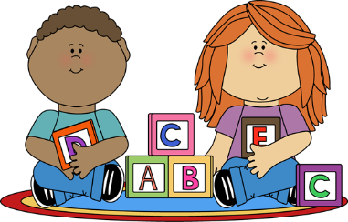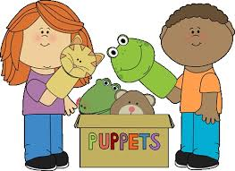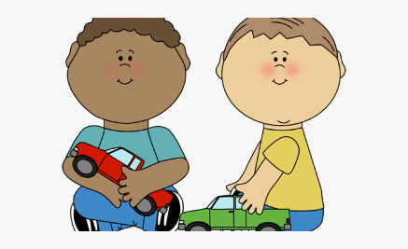

Before your child starts Saplings, please work on some of these things with them:

I can:

 walk independently

 feed myself with finger food, a spoon and drink with a cup

 helps with their nappy changing routine/ uses a potty with help

 pass a toy from one hand to other or bang them together

 hold a pencil to make big scribble like marks

 begins to make a tower with building blocks

 enjoy playing with or interested in creative materials such as; sand, water, play dough.

I can:

 move my body to music

 concentrate on something I like

 listens and joins in with short songs and rhymes

 may respond to what an adult says using familiar words

 understands simple sentences

 use my voice to make sounds and begin to copy sounds or words from others for example; ‘oh dear’ ‘all gone’

 points, uses gestures as well as single words

I can:

 play with toys and show an adult when I want attention

 notice others playing and show interest in what they are doing

 try to do things by myself and may say ‘no’ to an adult if they offer help

 understand rules and boundaries

 start to share things