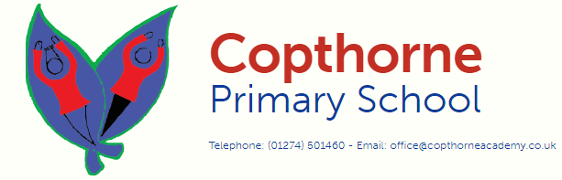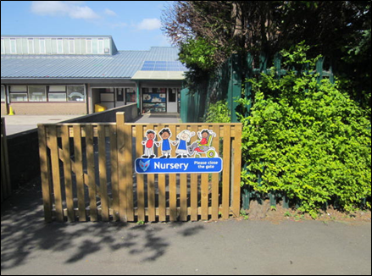

Nursery begins promptly at 8:30 for Acorns (AM) and 12:15 for Conkers (PM). Learning begins at these times so please ensure your child is on time every day. If you and your child arrive after this time, you **MUST** report to the school office, where your child will be escorted to their class and given a late mark.

If you have any questions please phone the school office or contact us.

Copthorne Primary School  
All Saints Road  
Bradford  
BD7 3AY

Tel: 01274 501460

Email: office@copthorneacademy.co.uk

If you come in the morning your class is called Acorns and if you come in the

afternoon your class is called Conkers.

Welcome to Nursery

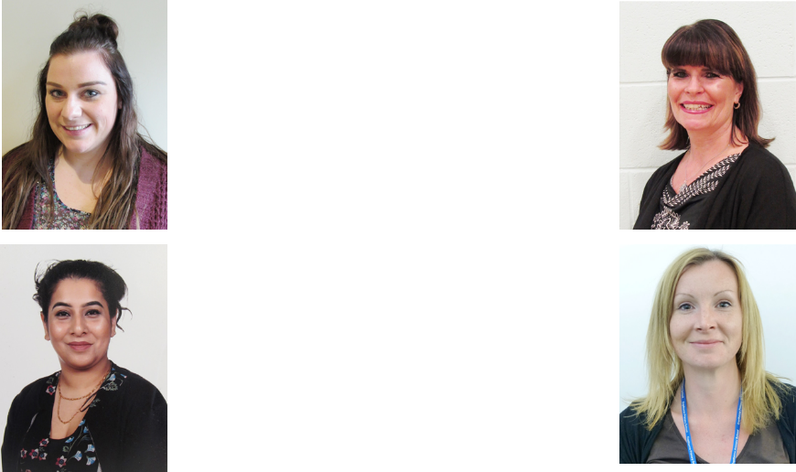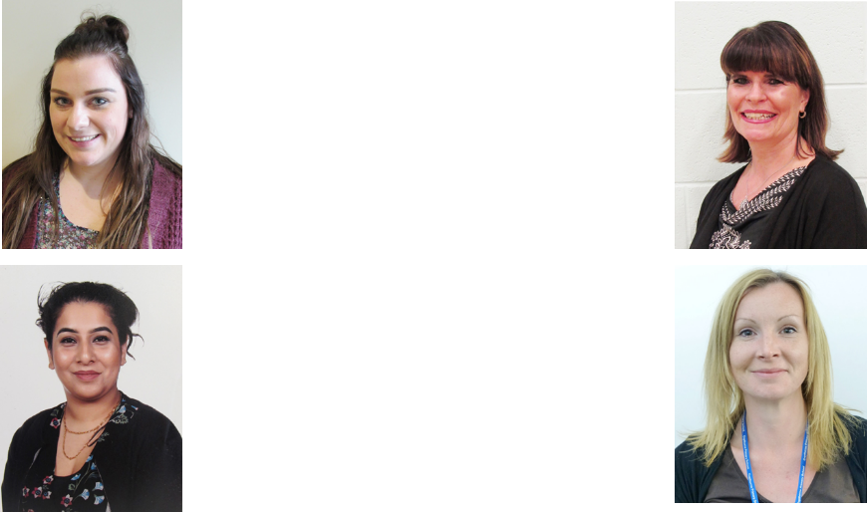

Nursery Teachers

Your child will be allocated to a Key Person. They will take a close interest in your child’s progress and individual needs.

Your child will spend time with their Key Person and their group at the start of every session. Please take your child to their key group when you drop them off. If you have any concerns about your child throughout their time in nursery you are advised to speak to your child’s Key Person.

Miss Birchall

Miss Thompson

Ms Sutcliffe

Mrs Gulzar

Please remember:

• Holidays **MUST NOT** be taken during school term time.

• If your child is ill, you must telephone the school office to notify us.

• Any medical appointments taken during the school day, must be pre-authorised by the Head of School.

• At Copthorne, we have a large number of children on the waiting list for our Nursery. If your child is persistently absent, they will risk losing their place to someone on the waiting list.

• Uniform **MUST** be worn at all times

• Jewellery and watches should not be worn as the school cannot accept responsibility for loss or damage to these.

• If you have any queries, concerns or questions please speak to your child’s Key Person, Miss Birchall or please contact the school office.

**We look forward to**

**seeing you in September!**

Miss Kneeshaw

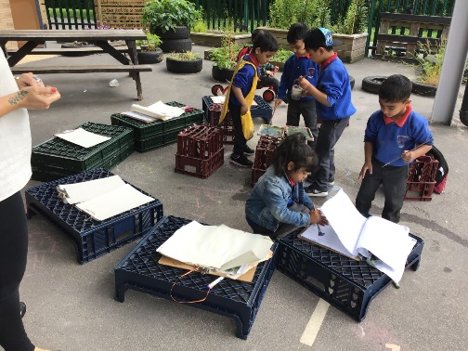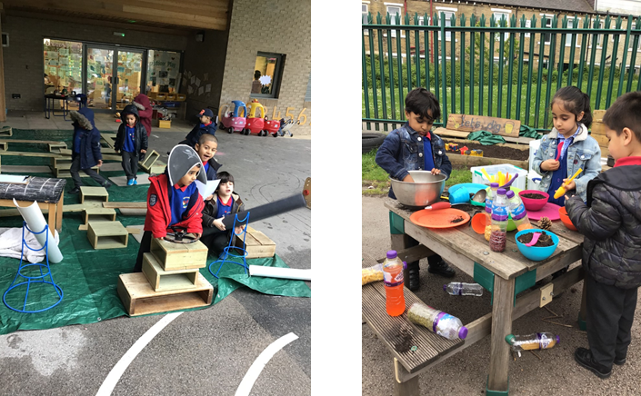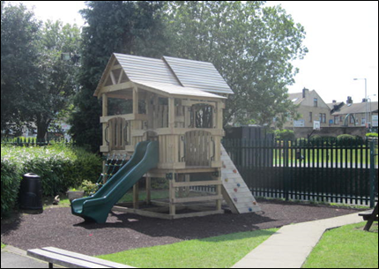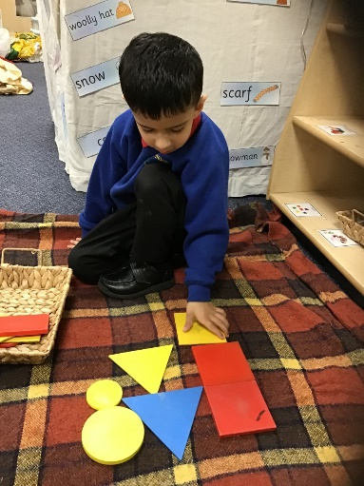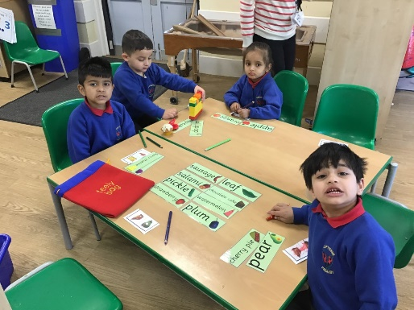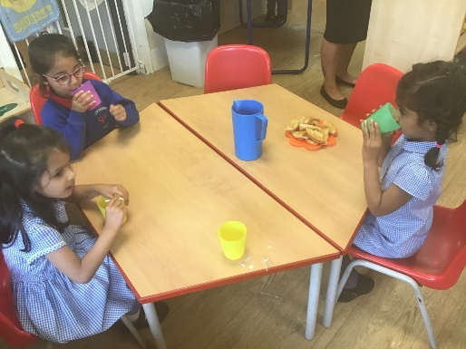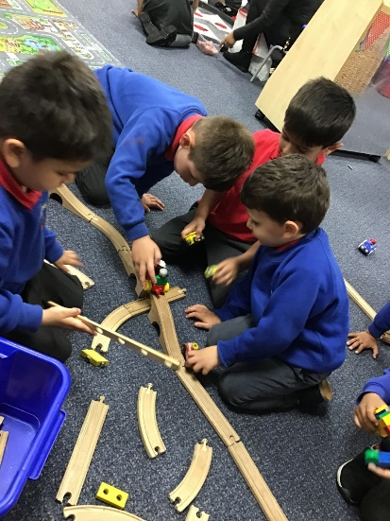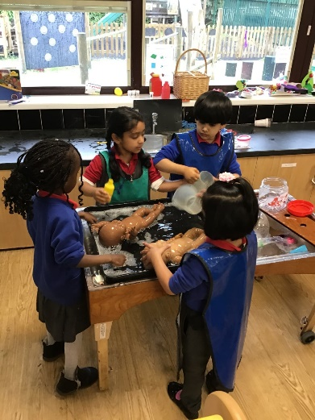

Nursery Outdoors

Nursery Classroom

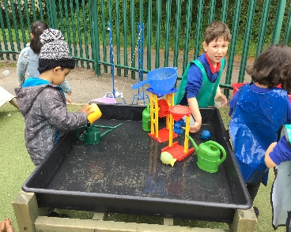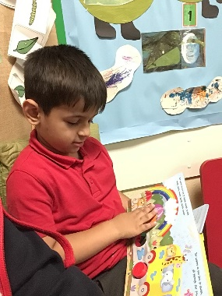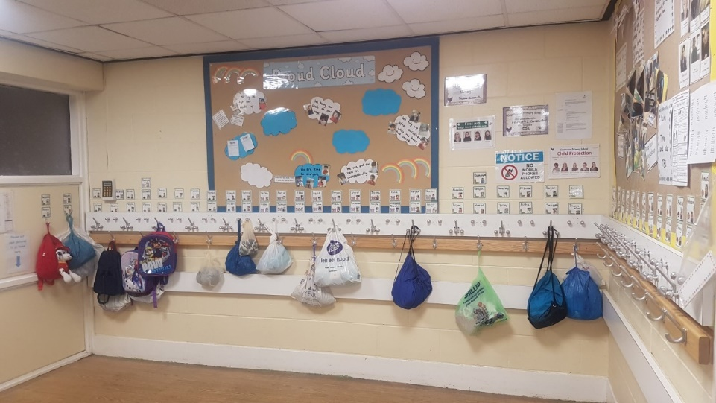

Where your things go

This is the cloakroom where you will have a peg with your name on. Please encourage your child to take their own coat off and hang it up so they can do it when you’re not there to do it for them!

If you make any pictures or models you can put them in the going home box and this will keep them safe so you can keep playing.

Please don’t bring any toys to school with you as they might get lost or broken.

What you can do in Nursery

In Nursery you play and share toys, talk to

others and pretend play. This helps to learn about your likes, interests and the world you live in as well as developing social skills. You will make friends. As well as building up your confidence to sing songs and rhymes and listen to stories.

You will learn about books, how to turn the pages, talk about the pictures and how to look after them.

 You will take part in activities which help to develop your body such as climbing, running, playing football, dancing, painting, drawing, using scissors, glue or dough, finger painting and sand and water play.

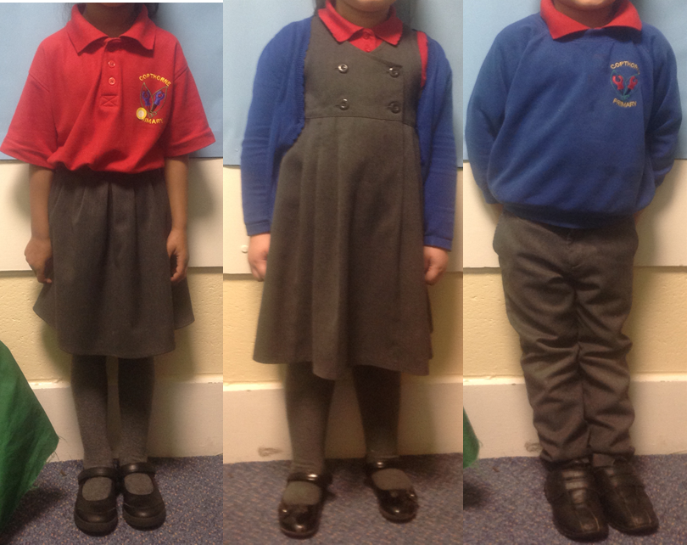

What you will wear

You will wear a school uniform and black shoes that you can put on and take off by yourself. Uniform can be purchased from Natasha’s in Bradford.

Please ensure **ALL uniform is clearly**

labelled with your child’s name, as we cannot be held responsible for any items of clothing going missing.

Things to talk about before you start

You will receive a pack with lots of information about school. This will give you chance to learn about your new class and teachers. There will be a chance to have a virtual meeting if you have any questions. We will also complete a home visit in

September. We do fully understand how hard the first few days at Nursery can be for all the family and we aim to support you with this. Please talk to your child about the uniform so they are excited to wear it.

Show them pictures and read this booklet with them and be positive about them

coming to school. If you pass school over summer, point it out to them, talk about siblings, friends or neighbours that attend Copthorne and please learn the adults names so they are familiar with us before they start Nursery.



It is really important to **talk to your child about the routine** so they know when they will see you again as this can give many children anxiety when settling in. We also encourage that you let them know they will go to sit on the carpet after they have got their coat on so we can then begin the home time routine safely.

cloakroom, carpet and story

tidy up and maths

indoor and outdoor areas

literacy or phonics

carpet time and register

home time

key group

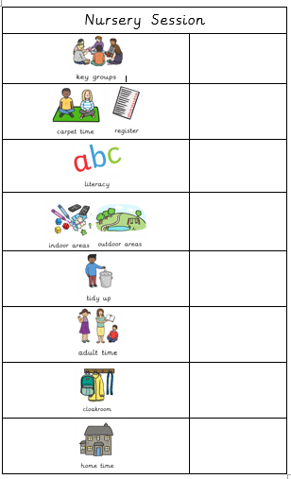

8.30 / 12.15

8.45 / 12.30

8.50 / 12.35

9.00 / 12.45

10.50 / 2.35

11.15 / 3.00

11.20 / 3.05

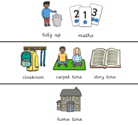

What a Nursery day looks like

Key Messages

• If your child needs any medicine, please speak to the office so the correct paper work can be completed beforehand.

• It is essential that Nursery has an inhaler or epi-pen in school at all times if your child requires one.

• It is advised that you support your child in going to the toilet once they have hung up their coat as this will help them feel comfortable in using them independently or with our support.

• If your child is in nappies please work on toilet training over the summer.

• Children’s hair must be of one length. At Copthorne, we do **not** allow lines and patterns to be shaved in to hair.

• If your child wishes to wear earrings, although this is not advised, they must be a plain, small stud only.

• Snack is on-going throughout the session. We encourage children to be independent and access this as they wish.