 | EYFS Newsletter | Copthorne Primary School  July 2020
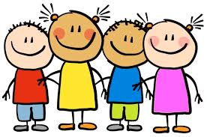
Home Learning
How to help at home  You can help your child to learn through the little things you do with them, for example:  - everyday conversations  - make-believe play  - games with numbers or letters  - reading together  - involving them in the things you are doing, such as household chores, and talking with them about it  You do not need to set separate time or plan complicated activities dedicated to learning. These activities can be built into everyday life and play. | Keeping active  Young children should be active for at least 3 hours a day in total. It’s also good to get some fresh air every day. If you do not have a garden and are taking children outside to exercise, make sure you follow the rules on social distancing.  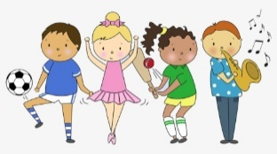  While inside, there are plenty of things you can do to keep children active, such as:  - playing hide-and-seek  - seeing who can do the most star jumps  - making an obstacle course  - copying dances from go noodle  - playing music and having a dance-off
Keeping a routine
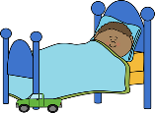
Do not worry about trying to keep to the full routine that your child had in Nursery. However, children will feel more comfortable with a predictable routine, so try to make sure they:
- get up and go to bed at the same time each day
- have regular meal times
- turn off any electronic devices, including the television, at least an hour before bedtime
Television and digital devices
There are lots of ways to help your child to learn such as reading together and make-believe play. You can also use what they have watched on television or the internet to help their learning. Talk with them about what they are watching or use their favourite television characters in other games and activities.

- Digital devices such as a laptop, desktop, tablet or smartphone can help some children learn. If your child does use them, try downloading some apps that will help them learn.
- Set age-appropriate parental controls on any devices young children are using and supervise their use of websites and apps. See advice on keeping them safe online.
- Try sharing things your child makes with your friends and family online and encourage others to do the same. Your child might enjoy seeing things they have made on the screen or seeing what other children have done.
- You can also visit ‘Hungry Little Minds’ for ideas of activities to do together without using a device.
Talking to your child about coronavirus (COVID-19)
Your child may ask you about what’s happening. They might be upset that they cannot do things they usually would, like see family or play on the swings, or some children may ask you about coronavirus (COVID-19) itself.

These are difficult things to talk to young children about and you may be worried about upsetting them. However, ignoring the subject could upset them more. Be open to talking to them about it. Reassure them that:
- you are there to keep them safe,
- they are unlikely to get poorly and you will look after them if they do,
- you would be looked after if you got poorly,
- give simple reasons for why you are doing things such as washing your hands and staying at home,
- listen to them carefully and answer the question they ask rather than giving them information they do not need.
Mental health and wellbeing
Staying at home and the change of routine may make this a difficult time for some children and they may be feeling a range of emotions about it.

They might get upset more often, or return to some behaviours they had grown out of. It’s understandable and other families will be experiencing this.

Try to keep your child away from news broadcasts that might scare them, take time to reassure them and be open to talking about their feelings. It’s normal for everyone to be feeling the strain in the current situation and for there to be some disagreements in the home. It will help your child’s wellbeing if they see those disagreements resolved in a healthy way. This will also help them learn how to resolve their own disagreements in the future.
Socialising while social distancing
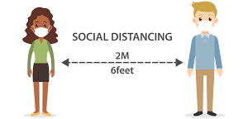
Spending time with other children is important for your child’s development, but at the moment it is important to follow the rules on social distancing.

While you are spending more time at home together, it will help them if everyone in the home talks with them through the day, responding to them and being led by the things they are interested in.

If you can, try a video call with other children. Younger children may not have a conversation as you would, but they can share activities or show each other things they have made or like. Try a call with other people that your child knows, such as grandparents.

