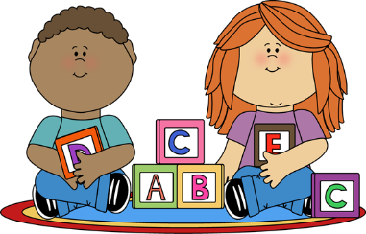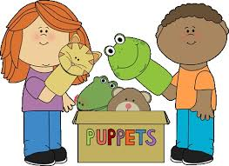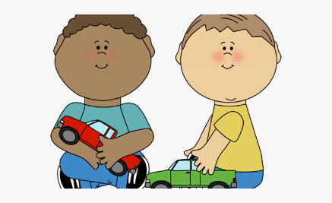

Before your child starts Nursery, please work on some of these things with them:

I can:

 feed myself with control and drink with a cup

 go to the toilet independently and ask for help if they need it

 hold a pencil to make circles and lines on paper

 begins to make their own ideas with resources such as; building blocks

 will help with dressing and will try to do own coat, shoes etc.

 enjoy playing with or interested in creative materials such as; sand, water, play dough.

I can:

 concentrate on something I like

 comment on what others are doing around them

 listens and joins in with short songs, rhymes and join in with actions

 will respond to what an adult says using short phrases

 understands and follow simple sentences/instructions

 listen to adults when they read stories

 answer their name when spoken to

 move my body to music

I can:

 play with toys and ask an adult when I need help

 notice others playing and show interest in what they are doing

 try to do things by myself and show a greater sense of

 independence

 understand rules and boundaries

 start to share things