COPTHORNE PRIMARY
SCHOOL

EYFS POLICY

Date of issue |  | Review date |  | Date ratified by Governing Body
 | Print name |  | Signature |  | Date
School Leader | Mrs C Shepherd
On behalf of Governing Body | Mrs N Hussain

Mission Statement
At Copthorne, we work together to provide high quality education that develops all children as lifelong learners and good citizens whilst equipping them for life in the wider world.
Copthorne Primary is a caring, friendly school which welcomes children and their families of all faiths and cultures. We recognise that every child is special and has individual needs. Our dedicated staff team works together with parents, governors and the community to ensure that each child develops the skills and knowledge to achieve, believing that there are no limits to what our children can learn. We believe that every child has a right to the very best possible learning experiences and that everyone can succeed. Our ethos is one of no excuses, high expectations and hard work resulting in the provision of learning experiences and opportunities which challenge, support and meet the academic, personal, social and spiritual needs of every child.
Aims of the Early Years
Early Years is made up of our 2 year old provision, Nursery and Reception.
We believe that all children are entitled to the best possible start to their school life, both emotionally and intellectually.
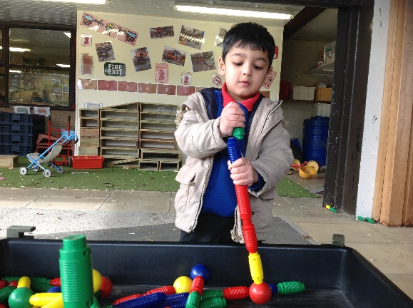
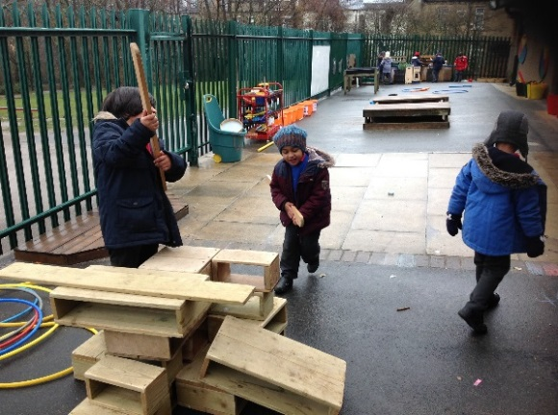

In order for them to develop their full potential, we aim to;
- Recognise all pupils as unique and special
- Understand that pupils develop in different ways at different times
- Provide a safe, secure and caring environment where pupils feel happy and valued
- Foster and nurture self-confidence and self-esteem by developing an awareness of their own identity and role in the community
- Teach them to express and communicate their needs and feelings in appropriate ways
- Encourage independence, decision-making and learning through mistakes
- Develop social skills, values and codes of behaviour to work together harmoniously
- Support pupils to develop care, respect and appreciation of beliefs, cultures and opinions that are different to their own
- Understand the importance of play
- Provide learning experiences that reflect pupil’s personal interest and curiosity to develop their natural desire, interest and excitement in order to motivate them to learn.
- Provide experiences that build on previous knowledge in order to challenge, stimulate and extend learning.
- Provide effective learning opportunities in a range of high quality environments with quality first teaching.
Early Years Curriculum
At Copthorne Primary School, teaching in Early Years is delivered in accordance with the ‘Statutory Framework for the Early Years Foundation Stage’ (March 2017). The framework outlines four guiding themes and principles that shape practice in early years settings. These are:

- Every child is a unique child
- Children learn to be strong and independent through positive relationships
- Children learn and develop well in enabling environments
- Children learn and develop in different ways and at different rates
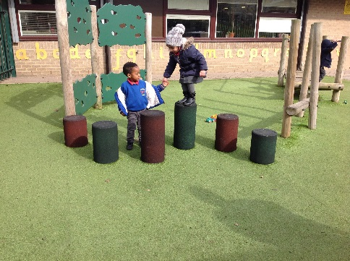

There are seven areas of learning and development that shape educational programmes in early years, all areas are important and are inter-connected. Three areas are particularly important in developing children’s curiosity, enthusiasm for learning, forming relationships and thriving. These three areas, the prime areas, are:
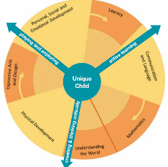
- Communication and language
- Physical development
- Personal, social and emotional development

As children grow and develop, the three prime areas are strengthened and applied through the 4 specific areas. These are:

- Literacy
- Mathematics
- Understanding the world
- Expressive arts and design

The specific areas of learning comprise the essential skills and knowledge that grow out of the prime areas and provide important contexts for learning.
To support each child in their learning journey we use the document ‘Development Matters’ to plan activities to give children learning experiences and opportunities to work towards achieving the Early Learning Goals. We recognise that the environment plays a key role in supporting and extending children’s development and plan for these opportunities to take place within the classroom and outside areas where they will participate in a variety of activities led by children, and activities led or guided by adults.
Through observation we assess the children’s interests, stages of development and learning needs, before planning challenging, achievable activities and experiences to extend the children’s learning.
Characteristics of Effective Learning
Characteristics of effective learning focus on the different ways that children learn. At Copthorne, staff across the EYFS plan and assess activities to reflect this in our practice.
The three characteristics are:
- Playing and Exploring – children investigate and experience things and ‘have a go’.
- Active Learning – children concentrate and keep on trying if they encounter difficulties and enjoy achievements.
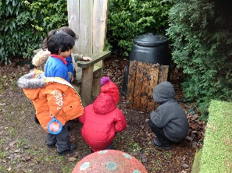
- Creating and Thinking Critically – children have and develop their own ideas, make links between ideas and develop strategies for doing things.
Role of the Key Person
Across EYFS each child is assigned a key person. Their role is to tailor provision to meet each child’s individual needs, to help the child become familiar with our setting, and build a supportive and caring relationship between the child and key person, as well as with the child’s parents. All adults within the Early Years setting actively seek to form positive, respectful relationships with the children in their care through regular meetings with parents regarding their child’s progress, open days, parent workshops and other family events.
Enabling Environments
At Copthorne Primary School, we recognise that the environment should develop the confidence of children, ensuring that they feel secure, yet challenged. The children have daily access to an indoor and outdoor environment that is set up in discrete areas of learning with planned continuous provision.
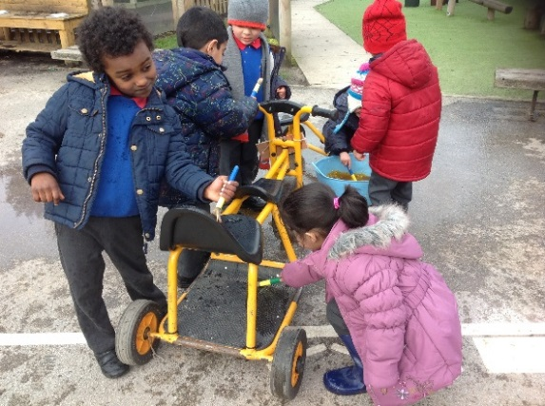
Play-based learning is paramount and children have opportunities to direct their own learning with planned opportunities provided by staff.

We plan a learning environment, both indoors and outdoors, that encourages positive attitudes to learning and reflects the individual’s interests, passions and abilities. Environments across the EYFS are resourced to reflect the community that the children come from and the global society in which we live. We encourage children to make their own selection of activities on offer to promote independent thinking and learning. We ensure that resources and spaces are safe to use and are checked regularly.
We have chosen to take an approach using resources that are open ended, natural and allow children to be creative in how they use them. Environments should enhance the children’s work and be presented in a way that is best for children to see what is relevant to their learning.
All children will be accessing the outdoors in all weathers. Parents are required to send suitable outdoor clothing for their child every day. The type of clothing needs to reflect the weather. Staff will ensure that children are appropriately dressed before allowing them to play outdoors.
It is not possible to refuse a child access to the outdoors areas and the organisation of the sessions allow free access between the indoors and outdoors environments. The only exception would be for a child with a care plan, where medical advice has recommended limited or restricted time outdoors. However, staff are to respect all cultural issues.
Delivery of Outdoor sessions:
- Outdoors will be planned around the developmental needs and interests of the children. Staff need to provide free play opportunities as well as some structured activities available throughout the day.
- Staff should be active and model movement for the children, they should promote fun and enjoyment in moving as well as the health benefits (raising heart rate).
- High quality resources will be provided both indoors and outdoors.
- The environment should be set up to ensure that there is a range of opportunities for physical activity as well as interactive purposeful play.
- The environment should enable the development of skills through selected equipment and activities.
- The activities should be appropriate for the children’s age and stage of development.
- There should be opportunities for challenge and to teach children about risk.
- Children must be supervised closely when using any equipment in the outdoor area.
- Staff must update the risk assessment of the outdoor area and equipment in relation to the children using it and take appropriate actions to support development and minimise risk.
- Staff will need to be able to adapt activities to ensure that all children have positive movement experiences to achieve success, through effective differentiation.
- Staff should promote the value of outdoor play.
- Promote independence and self-care opportunities.
- Staff support strategies for fair play.
- Ensure that all children have access to positive and purposeful outdoor play.
- Set up and store equipment safely and ensure sufficient challenge to exceed development.

Recording and Assessment
We will continue to use Early Essence to evidence physical play throughout the early years. In some instances, outdoor learning books will be provided for photos and children’s explanations to be placed inside. This will be used by the children to look through independently. Planning and children’s interests are recorded on the planning document. Whilst outside, the adult will use assessment for learning, in order to plan for the next steps in children’s play alongside;
- Annotating planning to ensure children’s learning is identified, and next steps are appropriately set for the children to extend play.
- Observing children in a wide range of contexts and ensuring observations are linked to the EYFS curriculum.
- Ensuring that gap analysis is the main document used when planning and setting up focused activities.
- Monitoring how children use the outdoor area and ask them their views when developing new ideas.

Parents as Partners
At Copthorne Primary School, we aim to establish good relationships with all parents and carers based on mutual respect and concern for the child. We value parents and carers as the child’s first educator and as active partners in the continuing process of education. When parents and practitioners work together in Early Years settings, the results have a positive impact on the child’s development and learning.

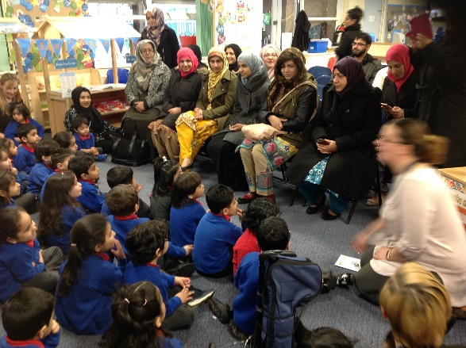

Links between the school and parents are developed by:

- Conducting a home visit in the secure, familiar environment of a child’s own home
- Providing transition days to support the smooth transition across the EYFS
- Inviting parents in to attend parent workshops as identified by the parents at the beginning of the year
- Inviting parents to an annual parent consultation evening.
- Inviting parents to a range of family events such as coffee mornings and assemblies.
- Providing a handbook of information
- Providing the school’s prospectus
- Collaborative partnership in achieving school expectations as outlined in the home school agreement
- Providing opportunities to regularly look at their child’s learning journey
- Providing communications through Marvellous Me
Alongside this we believe that setting boundaries for behaviour is important for the safety and protection of children and staff.
See Behaviour Policy
Equal Opportunities
At Copthorne Primary School, we are committed to anti- discriminatory practice for all children and families. We respect and value the diversity which exists in our wider community. We are committed to challenging attitudes that promote discrimination, ensuring respect for all and preparing all children for life in a diverse society. See Equality, Diversity and Cohesion policy.
SEND
All children are entitled to an education that enables them to:
- achieve the best possible educational outcomes, and
- become confident young children with a growing ability to communicate their own views and ready to make the transition into compulsory education
At Copthorne Primary School, we have clear systems and processes in place to identify and support children with SEN. We have a range of tools and materials to support the early identification of need which is important in order to develop effective provision to ensure children with SEN get the support they need to improve long term outcomes. We are also committed to working closely with parents, carers and other agencies to ensure children’s needs are met and best outcomes are achieved. See SEND policy
Teaching
Across EYFS, teaching varies to meet the needs of the children. In essence, teaching and learning will include a range of direct teaching, carefully planned adult-led experiences, child- initiated learning that is challenging and extended through continuous provision, and adult-led group activities.
Planning
All areas of learning are planned for. The learning opportunities provided include a range of child-initiated and adult-focussed activities to enhance learning.
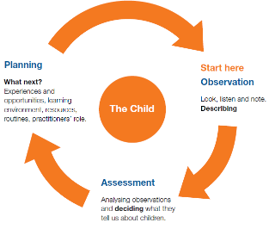
Planning is based on observations of the child’s learning and their next steps. It aims to provide individual teaching and learning to identify and address any gaps in the child’s learning and development.
All observations, planning and assessment ensure children are working towards the Early Learning Goals that should be achieved by the end of the Reception year.

Assessment
Ongoing assessment is an integral part of the learning and development process. Both formative and summative assessment, is essential in helping parents, carers and practitioners to recognise children’s progress and plan for the next steps in their learning.
At Copthorne we complete baseline assessments of all children within the first two weeks of a child entering the setting and include a focus on the child’s well-being and involvement.
Observations take place on a daily basis and involve practitioners observing children to understand their level of achievement and then shape learning experiences reflecting what they have observed ensuring that progress is made.
Observations of children are recorded on the Early Essence online assessment tool by all practitioners in the setting. Parents also have access to their child’s learning journey online which they can add to at any point.
All observation and assessment is rigorously moderated both internally and externally by members of the senior leadership team, the local authority, the EXCEED cluster group of schools, within the MAT and specialised consultants.
Progress Checks at Two
If a child starts in the setting at the age of 2 years old, we will carry out a review of their progress. This will be completed once they have settled and will be fed back to the parent/carer within the first half term of the child’s start date. Strengths and next steps will be discussed with the key person and advice given on how support can be given at home.
With consent from the parent/carer, the setting will contact the health visitor to share information.
Any concerns will be identified and, if appropriate, a clear individual education plan will be developed to support the child’s learning.
Where a child has attended a previous setting, staff will follow up relevant documentation to support the progress check.
Transition
Starting school can be a difficult time for young children. At Copthorne we plan for this carefully to ensure the transition is as smooth as possible for each child and supports them settling quickly and happily.
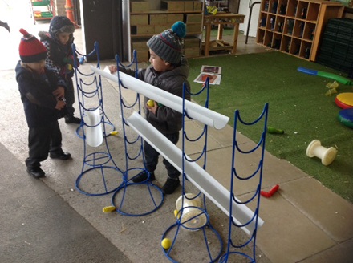
2 year old children
- Home visits before children start
- Planned visit days with parents
- Open event for all to come and look round
Nursery children
- Home visit x 2
- Planned visit days with parents
- Open event for all to come and look round
- Welcome packs for children
Reception children
- Home visits for children who are coming from other settings
- Parents’ open event
- Regular planned visits from Nursery into Reception in Summer 2
- Local authority transition day
- 3 sessions in their new class before the end of summer – all children coming from other settings invited
See Transition policy
Safeguarding
Children learn best when they are healthy, safe and secure, when their individual needs are met, and when they have positive relationships with the adults caring for them. We follow the safeguarding and welfare requirements detailed in the Early Years Foundation Stage Statutory Guidance (2017)
https://assets.publishing.service.gov.uk/government/uploads/system/uploads/attachment_data/file/596629/EYFS_STATUTORY_FRAMEWORK_2017.pdf
https://assets.publishing.service.gov.uk/government/uploads/system/uploads/attachment_data/file/550511/Keeping_children_safe_in_education.pdf
It is important to note that members of staff do not use their mobile phones or personal handset devices in the classroom and are prohibited from taking photographs with their personal handsets. This is in line with the school’s Child Protection policy. Members of staff do, however, use school IPads to take photographs as evidence to support the regular observation assessment cycle in the EYFS.
All parents are asked to state if they give permission for their child’s image to be used on the school website and for Early Essence through the paperwork in their initial starter packs which includes the Pupil Privacy Notice and consent form.
We take all accidents seriously, always logging these, and phone home immediately if a child bangs their head. We have cold compresses stored in the fridge. We encourage all children to start school without nappies but will support any children who require further support with this. We acknowledge that young children often have ‘accidents’ (i.e. wet themselves!). We have stocks of spare clothes and will change anyone who needs it. We ask parents to help keep our stocks of clothes high by returning anything their child has borrowed. Children are changed in the open area outside the toilets. All large climbing equipment is checked by our site officer and fire alarms are held regularly in line with whole school policy. There is an annual external check of equipment.
We follow whole school procedures for child protection (see separate policy). Christabel Shepherd (Executive Head Teacher), Stephanie Ngenda (Head of School), Claire Armitstead (Assistant Head), Emily Kneeshaw (Assistant Head), Helen Bradley (Assistant Head) and Suzy Wood (SEND-co) are the named Child Protection Officers and all concerns can be discussed with them. We have separate policies for medicine in school and off-site visits.

Safety is paramount and the school has a robust and effective Safeguarding policy to ensure the children in our care are protected (see whole school policy).

Safety and security is a high priority and it is important that all children in our care are safe. Our requirements are stated in the Statutory Framework for Early Years Foundation Stage 2017.

The daily experience of children in the setting and the overall quality of provision depends on all practitioners having appropriate qualifications, training, skills and knowledge and a clear understanding of their roles and responsibilities. We ensure that all staff receive induction training to help them understand their roles and responsibilities. Induction training includes information about emergency evacuation procedures, safeguarding, child protection, an understanding of the equality policy, and health and safety issues. We support staff to undertake appropriate training and professional development opportunities to ensure that staff offer quality learning and development experiences for children. Staffing ratios and qualifications vary across EYFS and are as follows:

2 year olds:
- There must be at least one member of staff for every four children
- At least one member of staff must hold a full and relevant level 3 qualification
- At least half of all other staff must hold a full and relevant level 2 qualification

3 year olds

• There must be at least one member of staff for every 13 children

• At least one member of staff must be a school teacher as defined by section 122 of the Education Act 2002

4 year olds

Reception classes in maintained schools are subject to infant class size legislation. The School Admissions (Infant Class Size) Regulations 2012 limit the size of infant classes to 30 pupils per school teacher while an ordinary teaching session is conducted. ‘School teachers’ do not include teaching assistants, higher level teaching assistants or other support staff. Consequently, in an ordinary teaching session, a school must employ sufficient school teachers to enable it to teach its infant classes in groups of no more than 30 per school teacher.
Food Hygiene
All food provided is healthy, balanced and nutritious. All staff members have Food Hygiene Level 1 certificates and follow the correct food hygiene procedures when preparing food and drink.
Fresh water is available at all times and children can access the snack area throughout the session. We record any dietary needs and display these in the appropriate areas. Children are supervised and encouraged to be independent in eating and drinking.
Safety of Premises

We ensure our premises, including overall floor space and outdoor spaces, are fit for purpose and suitable for the age of children cared for and the activities provided on the premises. We comply with requirements of health and safety legislation (including fire safety and hygiene requirements).

We take reasonable steps to ensure the safety of children, staff and others on the premises in the case of fire or any other emergency, and have an emergency evacuation procedure. We have appropriate fire detection and control equipment (for example, fire alarms, smoke detectors, fire blankets and/or fire extinguishers) which are in working order and checked regularly. Fire exits are clearly identifiable, and fire doors are free of obstruction and easily opened from the inside.

We have a no smoking policy on our premises. (see Non-Smoking policy).

