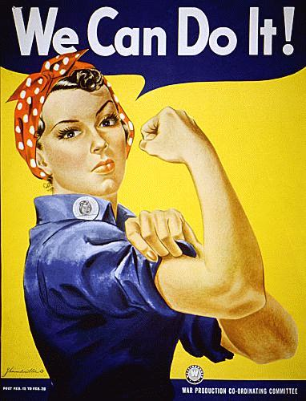
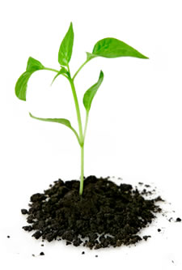
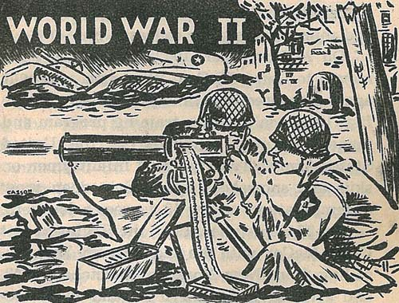
As Scientists we will be learning about farming and green plants and what they need to grow healthily. We will compare our diet today with the wartime diet, and decide which is healthier.

Year 4 Creative Curriculum
Theme 1 (Autumn term)
World War Two
Areas of Learning

As Historians we will be studying Britain during World War 2. We will be visiting Eden Camp and the Industrial Museum. We will be finding out about the key events of World War 2 and how they affected the people of Britain at the time and how they have shaped our lives today.

As Artists, we will explore the impact of propaganda art and wartime advertisements.

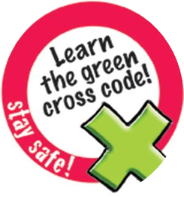

In PSCHE, we will be comparing democracy with dictatorship and discussing the rights and responsibilities of citizens in a democracy.

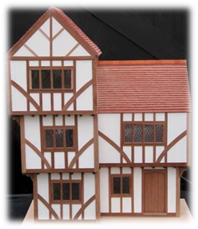


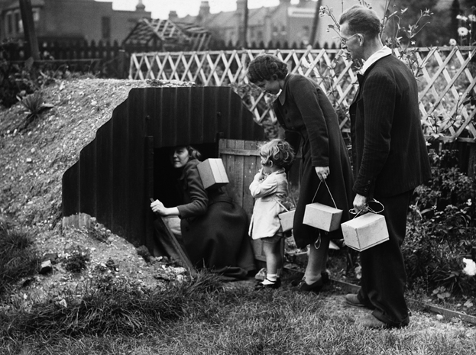
As Design Technologists, we will investigate and make Anderson shelters using mouldable materials (clay). We will explore the uses and types of shelter and make our own shelters. We are going to design and make a wartime meal using fresh vegetables and rationed foodstuffs.

We will also use our ICT skills to research aspects of the Second World War and present our findings using Powerpoint.

During PE we will be playing hockey and investigating balance in gymnastics.
Environmental Awareness | Cultural Awareness and understanding | Community | Outdoor learning
We will find out how far our food travels to reach us today, and compare this with the 1940s. | We will find out how the Nazis treated Jews and how the British treated Allied soldiers from other countries who settled in Britain after the war. | We will find out about the “community spirit” which prevailed during the war. | We will hold our own street party to celebrate the end of the war.  Forest Schools.  Trip to Eden Camp.  Digging the allotment.

